Week 2

Part 1

Q1) Yes I have done some programming but not a lot of it. I programmed a hello world program in python.

Q2) I am doing computer science because I have an interest in computers and have been interested in working with them ever since I was younger.

Q3) My favourite website is youtube, because I spend majority of the time on my computer on it. My favourite app is snapchat because it is entertaining to use. My favourite piece of software is google chrome because you can connect to the internet through it.

Q4) I wish I had created a successful piece of software or app so that I could make lots of money.

Q5) I like football, rugby, basketball, cycling, kayaking and I am interested in computers and computer games and also socialising with friends and new people.

Q6) I knew where I wanted to go to college since I was 12 years of age and haven’t changed my mind since.

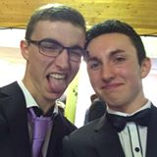

Part 2

Problem 1: There is a farmer, a chicken ,a fox and chicken feed stuck on an island. There is only one boat to get off the island, however, if the chicken and the fox are left alone, the fox will eat the chicken and if the chicken and the feed are left alone, the chicken will eat the feed, the farmer can take two things and himself on the boat and can only drop of one thing at a time, how can they all get off the island to safety?

Farmer = A, Fox = B, Chicken = C, Feed = D

|  |  |  |  |
| --- | --- | --- | --- |
| **Turn** | **Island** | **Trip** | **Safety** |
| 1 | ABCD | ABC | B |
| 2 | D | AC | B |
| 3 |  | ACD | BD |
| 4 |  |  | ABCD |

Problem 2: At the recent downhill mountain bike race, four entrants entered the challenging slalom event

* Alan came first.
* The entrant wearing number 2 wore red, whereas John didn't wear yellow.
* The loser wore blue and Steve wore number 1.
* Kev beat Steve and the person who came second wore number 3.
* The entrant in yellow beat the entrant in green.
* Only one of the entrants wore the same number as their final position.

|  |  |  |  |  |
| --- | --- | --- | --- | --- |
| **Steps** | **Alan** | **Kev** | **Steve** | **John** |
| **1** | Alan is 1st | Beat steve | Wore number 1 | John didn’t wear yellow |
| **2** | Not wearing yellow due to point 3 | Wearing yellow as Alan and John didn’t wear yellow and point 3 | Steve is wearing green as Kev beat him | Wearing blue as Kev and steve are wearing other colours and point 3 |
| **3** | Wearing Red and wearing number 2 | Wearing number 3 | Finished 3rd | Wearing number 4 |
| **4** |  |  |  |  |
| **5** |  |  |  |  |
| **6** |  |  |  |  |

Can you determine who finished where, the number and colour they wore?

Alan is wearing red, finished in first and is wearing number 2

Kev is wearing yellow, finished in second and is wearing number 3

Steve is wearing green, finished in third and is wearing number 1

John is wearing blue, finished in last and is wearing number 4

References

<http://www.brainbashers.com/showpuzzles.asp?puzzle=ZNLA>

Week 3

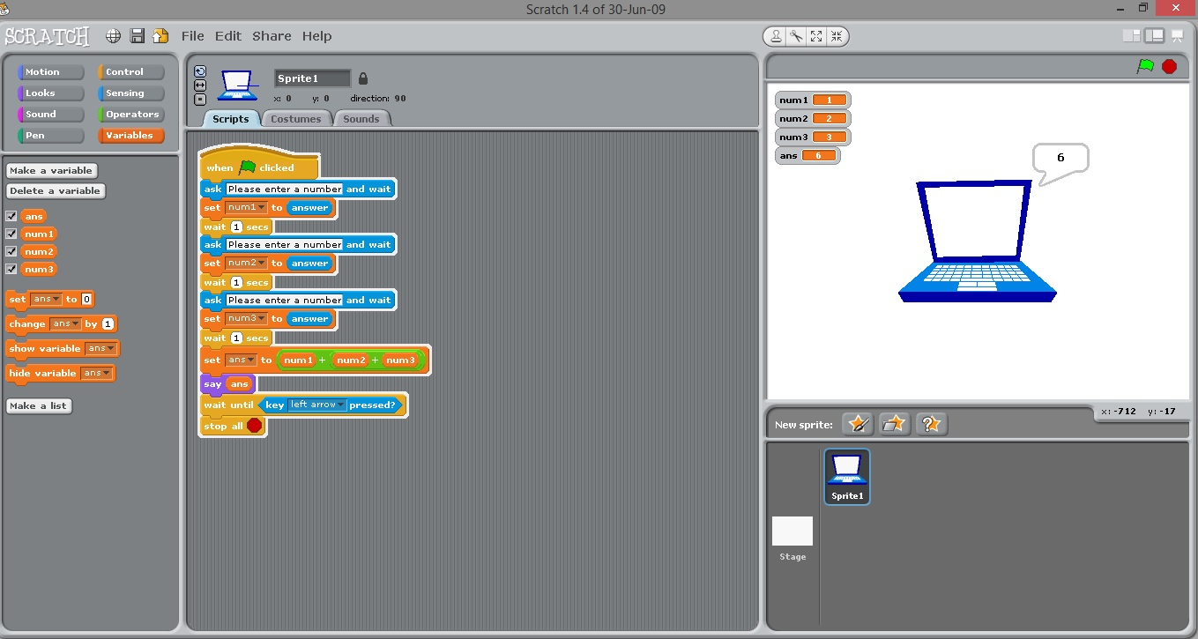

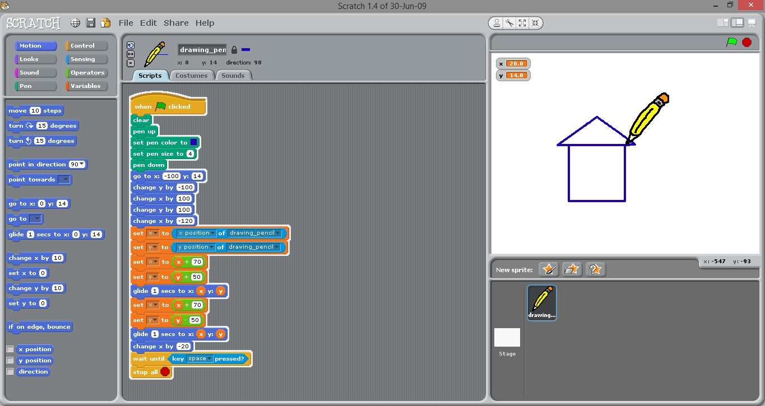

Week 4

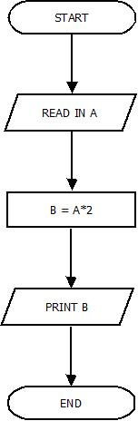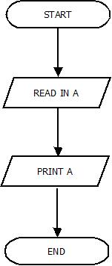Diagram 1 Diagram 2

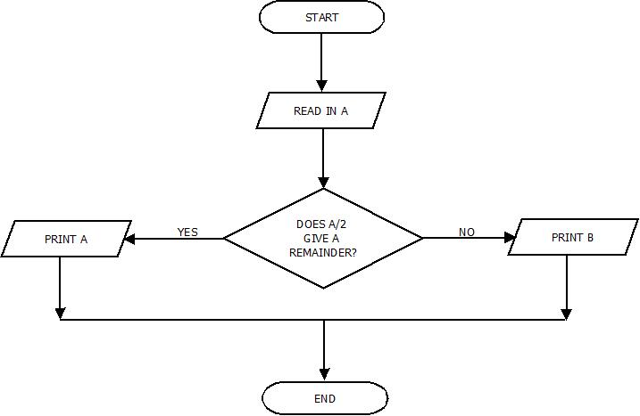 Diagram 3

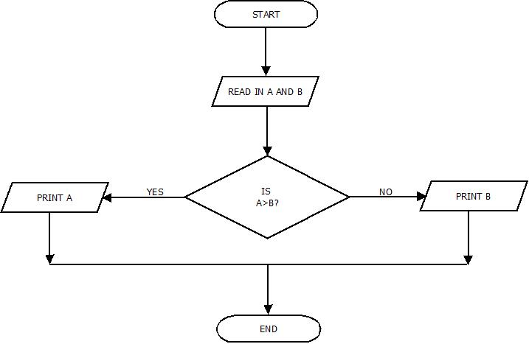 Diagram 4

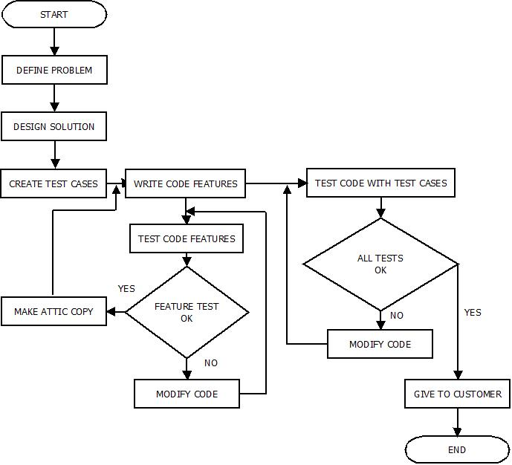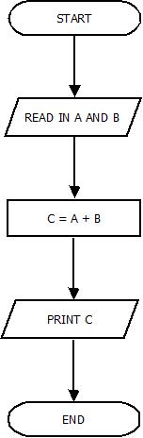 Diagram 5 Diagram 6

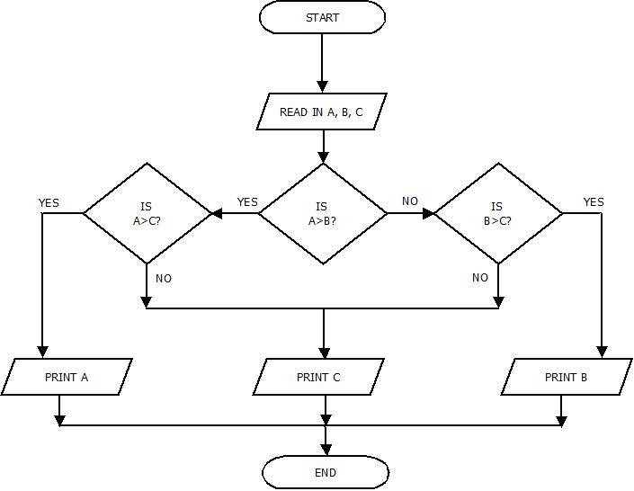Diagram 7

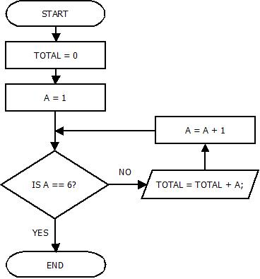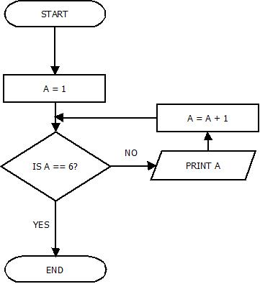Diagram 8 Diagram 9

Diagram 10

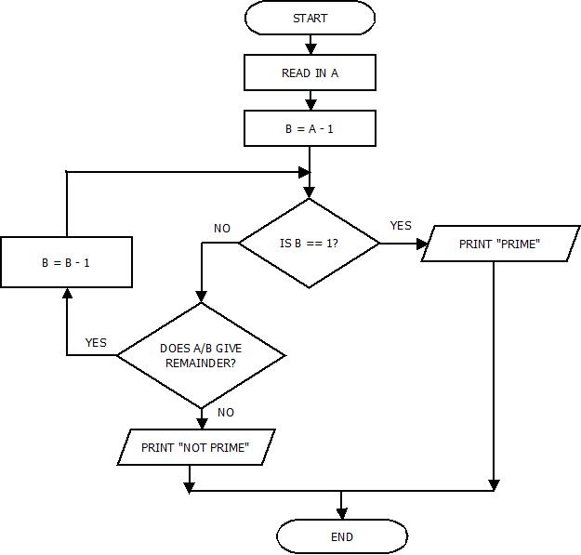

Week 5

Tutorial 3 – Exercise 4

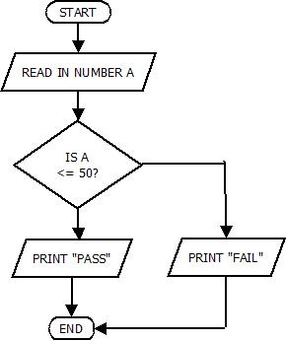

Diagram 14

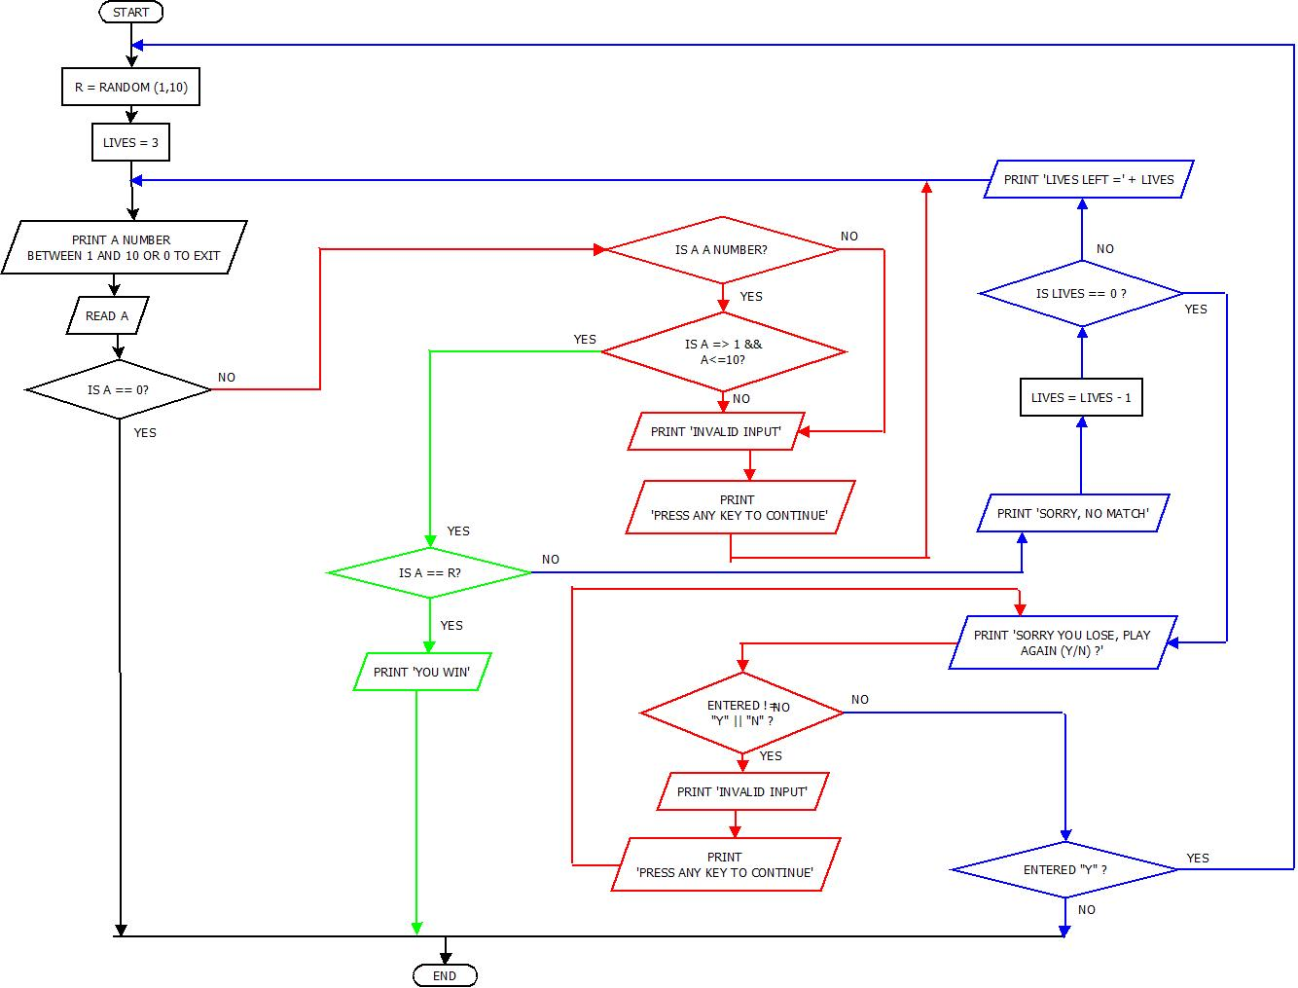

Diagram 15 Diagram 16

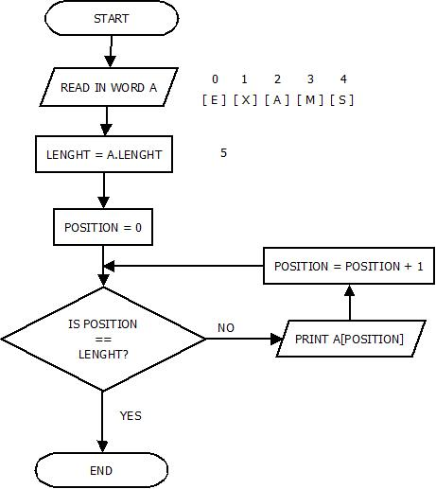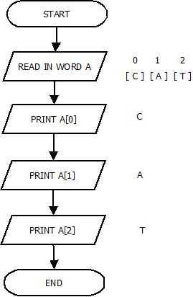

Diagram 17

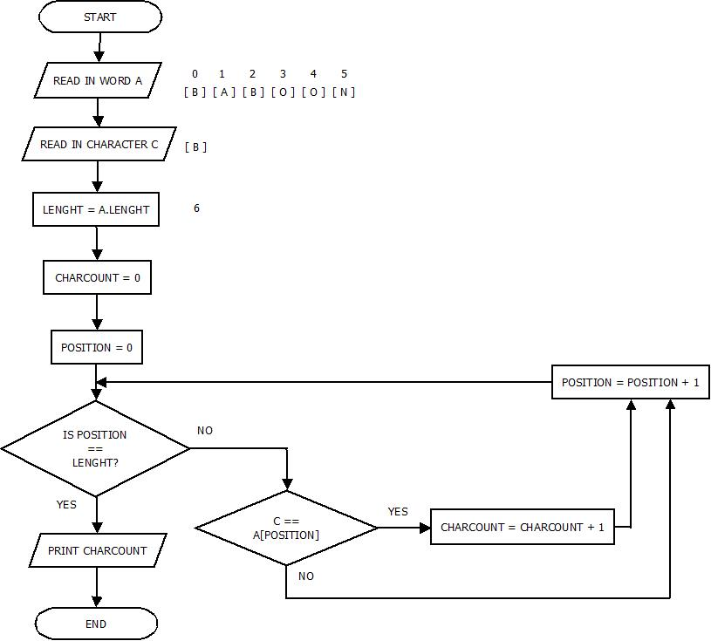

Diagram 18 Diagram 19

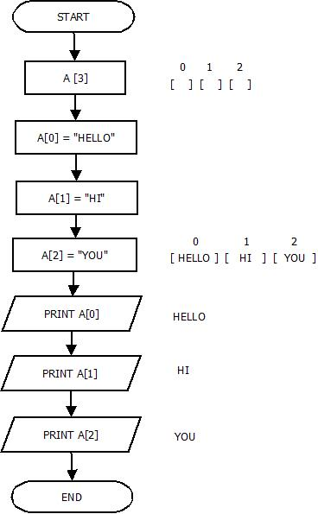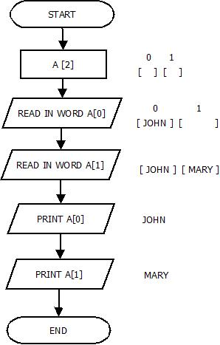

Diagram 20

